AI Agent System Specification: Biomechanical Strength Classifier
This document defines the mathematical logic, reference values, and classification workflow required to dynamically calculate a lifter's strength tier (Novice, Intermediate, Advanced, Elite).

1. Input Variables
- gender: "male" or "female"
- weight_kg: Lifter's bodyweight in kilograms (float)
- height_cm: Lifter's height in centimeters (float)
- lift_type: "squat", "bench", or "deadlift"
- actual_lift_kg: The lifter's actual 1-Rep Max (1RM) in kilograms (float)

2. Constants & References

A. Reference Athlete Anchors (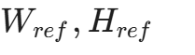)
- Male Reference: 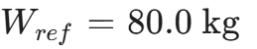, 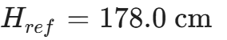
- Female Reference: 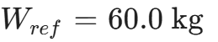, 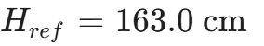

B. Base Multipliers (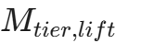)
Gender | Lift | Novice | Intermediate | Advanced | Elite
Male | Squat | 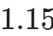 | 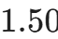 | 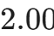 | 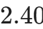
 | Bench | 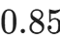 |  | 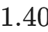 | 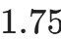
 | Deadlift | 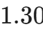 |  | 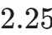 | 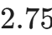
Female | Squat | 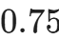 | 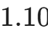 |  | 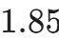
 | Bench | 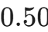 |  | 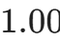 | 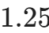
 | Deadlift | 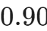 |  |  | 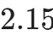

3. Mathematical Calculations (Step-by-Step)

Step 1: Allometric Scaling (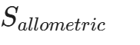)
Adjusts the lifter's weight using the 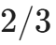 scaling law to account for dimensional body differences.

Step 2: Leverage Correction Factor (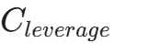)
Adjusts targets by 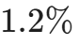 per centimeter deviation from the reference height.

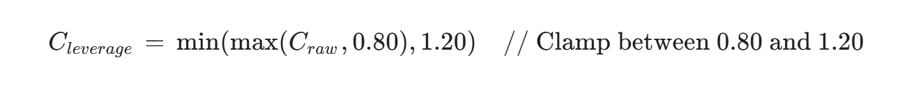Step 3: Calculate Dynamic Targets for All Tiers (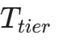)
Calculate the required weight targets for each of the four tiers:

4. Classification & Progress Workflow
- Evaluate Tier: Compare actual_lift_kg against the calculated targets ().
  - If actual_lift_kg 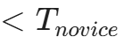 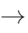 Below Novice
  - If 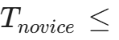 actual_lift_kg 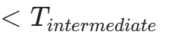  Novice
  - If 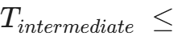 actual_lift_kg 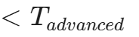  Intermediate
  - If 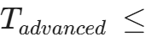 actual_lift_kg 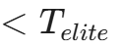  Advanced
  - If actual_lift_kg 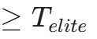  Elite
- Calculate Progress to Next Tier (%):
  - Identify the boundary targets 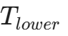 (current tier target) and 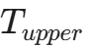 (next tier target).
  - Note: If "Below Novice", 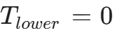, 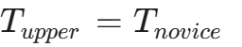. If "Elite", progress is 
